**PHP**

1.PROGRAM TO FIND THE REVERSE OF A GIVEN NUMBER IN PHP

<?php

$num = 23456;

$revnum = 0;

while ($num > 1)

{

$rem = $num % 10;

$revnum = ($revnum * 10) + $rem;

$num = ($num / 10);

}

echo "Reverse number of 23456 is: $revnum";

?>

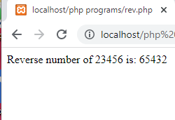

2.PROGRAM TO FIND THE FIBONACCI SERIES

<?php

function Fibonacci($n){

$num1 = 0;

$num2 = 1;

$counter = 0;

while ($counter < $n){

echo ' '.$num1;

$num3 = $num2 + $num1;

$num1 = $num2;

$num2 = $num3;

$counter = $counter + 1;

}

}

$n = 10;

Fibonacci($n);

?>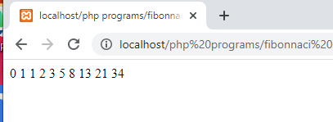

3.WRITE A PROGRAM IN PHP TO PRINT A TABLE OF NUMBER

<?php

define('a', 9);

for($i=1; $i<=10; $i++)

{

echo $i*a;

echo '<br>';

}

?>

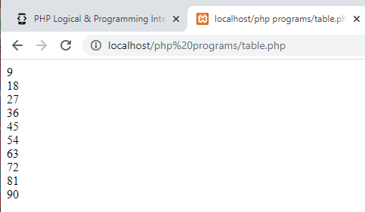

4.PHP CODE TO FIND WHETHER A NUMBER IS ARMSTRONG OR NOT

<?php

function armstrongCheck($number){

$sum = 0;

$x = $number;

while($x != 0)

{

$rem = $x % 10;

$sum = $sum + $rem*$rem*$rem;

$x = $x / 10;

}

if ($number == $sum)

return 1;

return 0;

}

$number = 153;

$flag = armstrongCheck($number);

if ($flag == 1)

echo "Yes";

else

echo "No"

?>

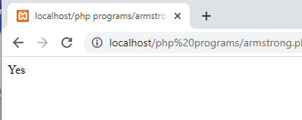

5. PROGRAM TO FIND A STRING IS PALINDROME OR NOT

<?php

function Palindrome($number){

$temp = $number;

$new = 0;

while (floor($temp)) {

$d = $temp % 10;

$new = $new * 10 + $d;

$temp = $temp/10;

}

if ($new == $number){

return 1;

}

else{

return 0;

}

}

$original = 257752;

if (Palindrome($original)){

echo "Palindrome";

}

else {

echo "Not a Palindrome";

}

?>

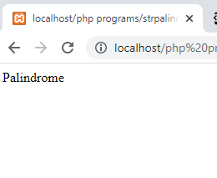

6.PROGRAM TO FIND THE FACTORIAL OF A NUMBER

function Factorial($number){

if($number <= 1){

return 1;

}

else{

return $number * Factorial($number - 1);

}

}

$number = 20;

$fact = Factorial($number);

echo "Factorial = $fact";

?>

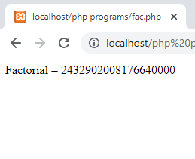

7. PROGRAM TO FIND NUMBER OF DAYS BETWEEN 2 DATES IN PHP AS FOLLOWS:

Let the dates are 25-09-2020 and 31-01-2021

<?php

function dateDiffInDays($date1, $date2)

{

$diff = strtotime($date2) - strtotime($date1);

return abs(round($diff / 86400));

}

$date1 = "25-09-2020";

$date2 = "31-01-2021";

$dateDiff = dateDiffInDays($date1, $date2);

printf("Difference between two dates: ". $dateDiff . " Days ");

?>

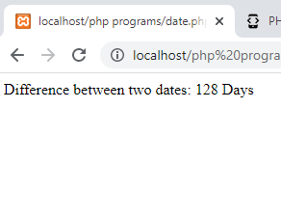

8..SWAPPING 2 NUMBERS IN PHP

<?php

$a = 45;

$b = 78;

// Swapping Logic

$third = $a;

$a = $b;

$b = $third;

echo "After swapping:<br><br>";

echo "a =".$a." b=".$b;

?>

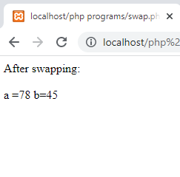

9.. PROGRAM TO CALCULATE AREA OF RECTANGLE BY INSERTING VALUES IN A FORM

<html>

<body>

<form method = "post">

Width: <input type="number" name="width">

<br><br>

Length: <input type="number" name="length"> <br>

<input type = "submit" name = "submit" value="Calculate">

</form>

</body>

</html>

<?php

if(isset($_POST['submit']))

{

$width = $_POST['width'];

$length = $_POST['length'];

$area = $width*$length;

echo "The area of a rectangle with $width x $length is $area";

}

?>

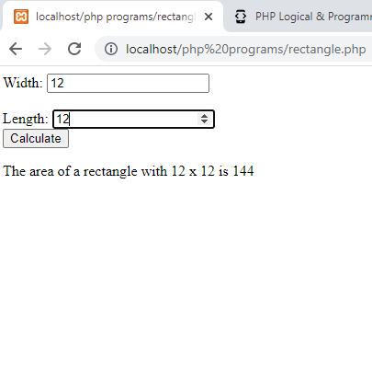

10.PHP NUMBER TRIANGLE PROGRAM

<?php

for($i=0;$i<=5;$i++){

for($j=1;$j<=$i;$j++){

echo $j;

}

echo "<br>";

}

?>

